Assembly Dems: Senate GOP Wants To Cut 2 Dems In Congress
Posted by: Jon Campbell

Posted in Uncategorized on Feb 29, 2012
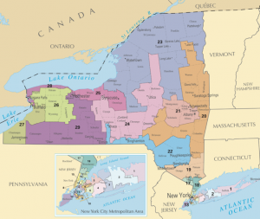
A spokesman for the Assembly Democratic majority said this morning that Senate Republicans are proposing to eliminate a pair of Congressional districts currently held by Democrats, which has become a major sticking point in negotiating new maps.

Michael Whyland, the spokesman, said the Senate GOP is trying to preserve Rep. Bob Turner’s Queens seat by sweeping conservative neighborhoods from neighboring districts, and are proposing to cut the Queens/Nassau County district currently held by Rep. Gary Ackerman, a Democrat. They’re also looking at eliminating the 22nd Congressional District, currently held by retiring Rep. Maurice Hinchey, D-Hurley, Ulster County, according to Whyland.

Ackerman represents the 5th Congressional District. (Click to enlarge the map.)

Turner, a Republican, pulled off a surprise win in a special election last year in his largely Democratic district. He replaced Rep. Anthony Wiener, who resigned amid scandal.

Assembly Democrats say the Senate GOP’s plan would hurt voters in the outer boroughs of New York City, Whyland said. The conference also isn’t in favor of eliminating two Democratic districts, for obvious reasons.

“For them, they go in and grab a conservative bloc of voters and eliminate two Democratic districts—Congressman Hinchey and Congressman Ackerman’s districts would be jeopardized,” Whyland said. “It really does sacrifice Queens voters.”

Senate GOP spokesman Scott Reif declined to comment specifically on his conference’s plan. “We’ll be submitting a plan,” he said. “We’re prepared to submit our plan later today.”

Beginning with this year’s election cycle, New York will elect two fewer representatives to Congress because it grew at a slower rate than other states in the 2010 census.

Whyland declined to discuss the specifics of the Assembly Democrats’ own proposal, but said the conference will file its own map today. A panel of federal judges ordered the Legislature to submit its proposals for Congressional maps by the end of today so they can be considered by a “special master” who has intervened in the redistricting process.

Both Whyland and Reif said the two conferences—which control the majority in their respective houses—are still discussing their Congressional proposals through the day, but both expect to file separate plans. Assembly Democrats and the Senate GOP control LATFOR, the Legislature’s task force in charge of drawing new state and federal maps every 10 years.

